Master of Business Administrative

(Artificial Intelligence and Data Science)



GRAPHIC ERA DEEMED TO BE UNIVERSITY

DEHRADUN (UTTARAKHAND)

Session : 2025-26

Project Title - ETL Process using SSIS (Northwind Data Warehouse)

Submitted By –
Divyanshi Sharma (24262613)
Pratik Shubham (24261607)
Manas Bhargava (24521029)
Sharmeen Fatima (24262615)

Submitted To – Prof Abhijeet Thapa

Course - (MBA AI&DS)

Date – 9th May 2026

SQL Script for Creating FactOrders Table
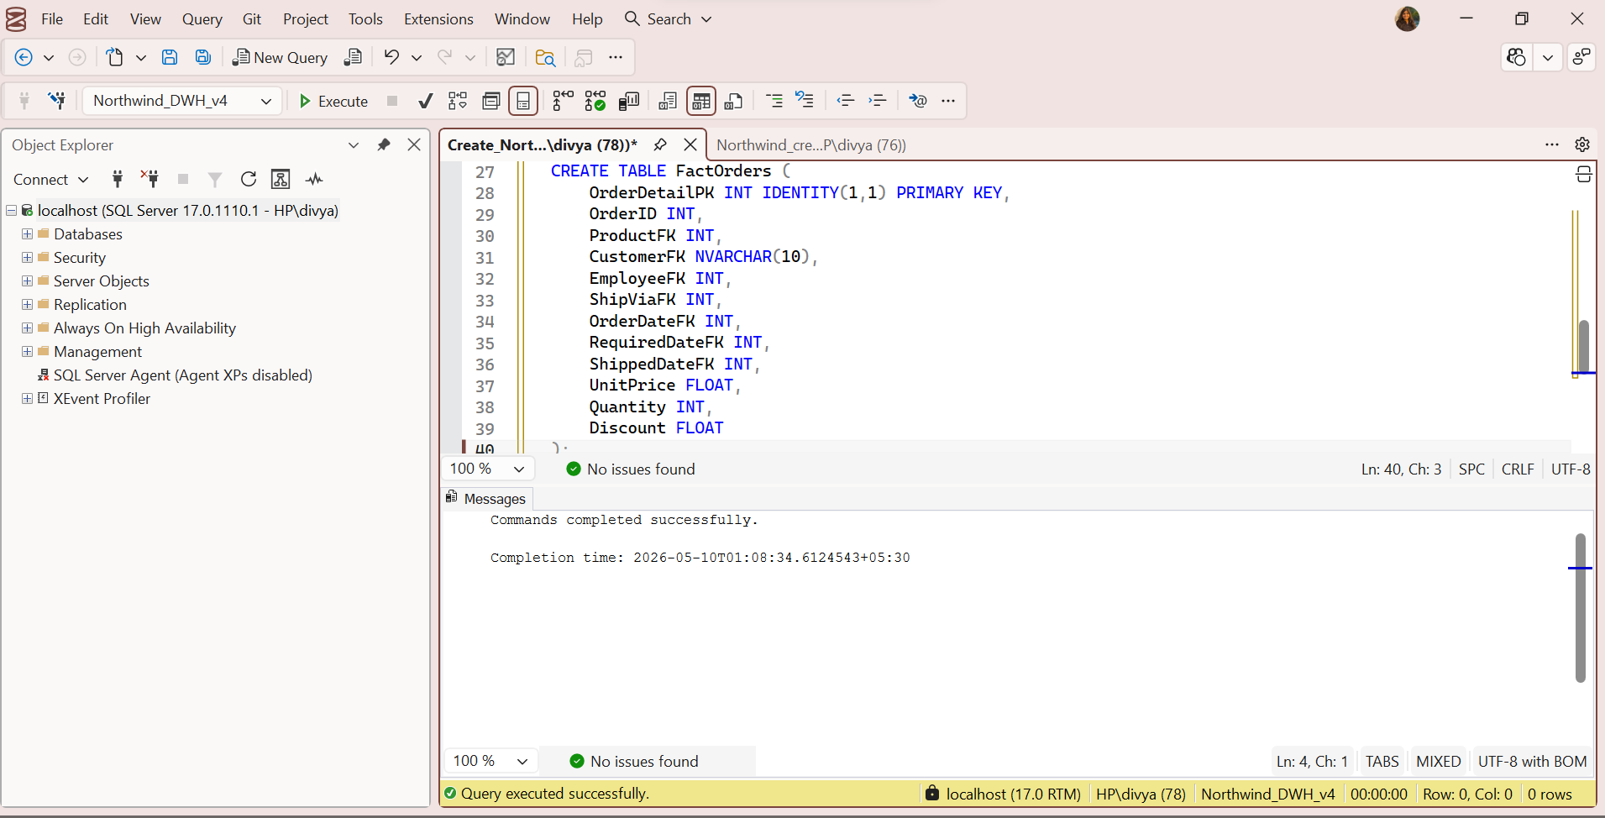
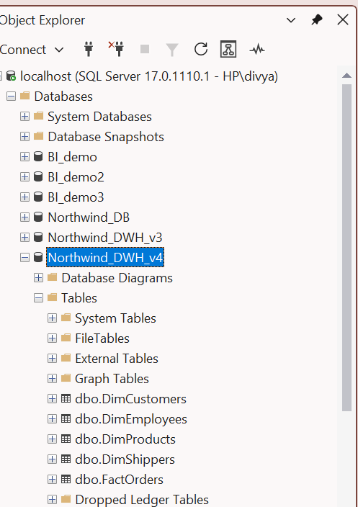

- Created FactOrders table in data warehouse
- Defined primary key (OrderDetailPK)
- Added foreign keys (CustomerFK, ProductFK, EmployeeFK, etc.)
- Included measure columns (UnitPrice, Quantity, Discount)
- Query executed successfully

FactOrders Table Created in Database (SSMS Object Explorer)

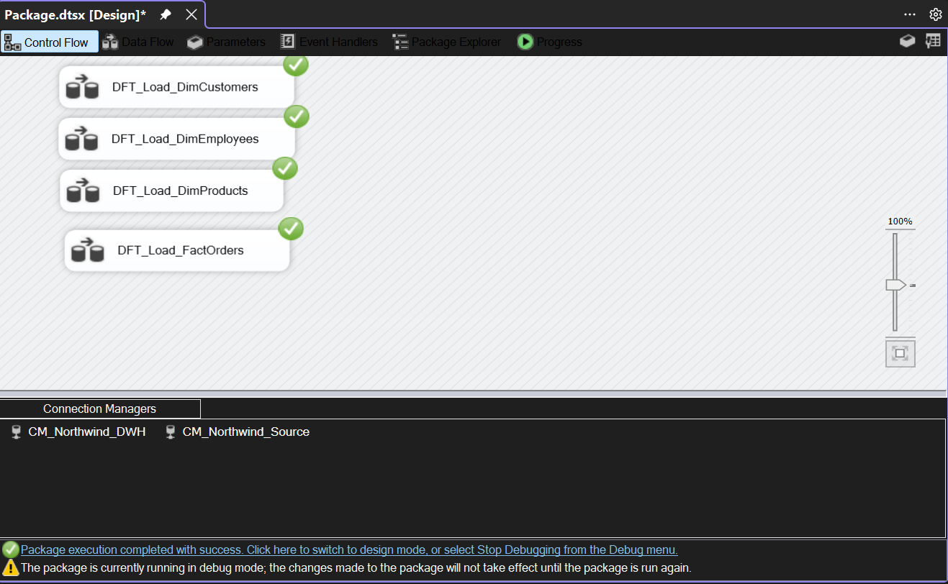

ETL Process for DimCustomers

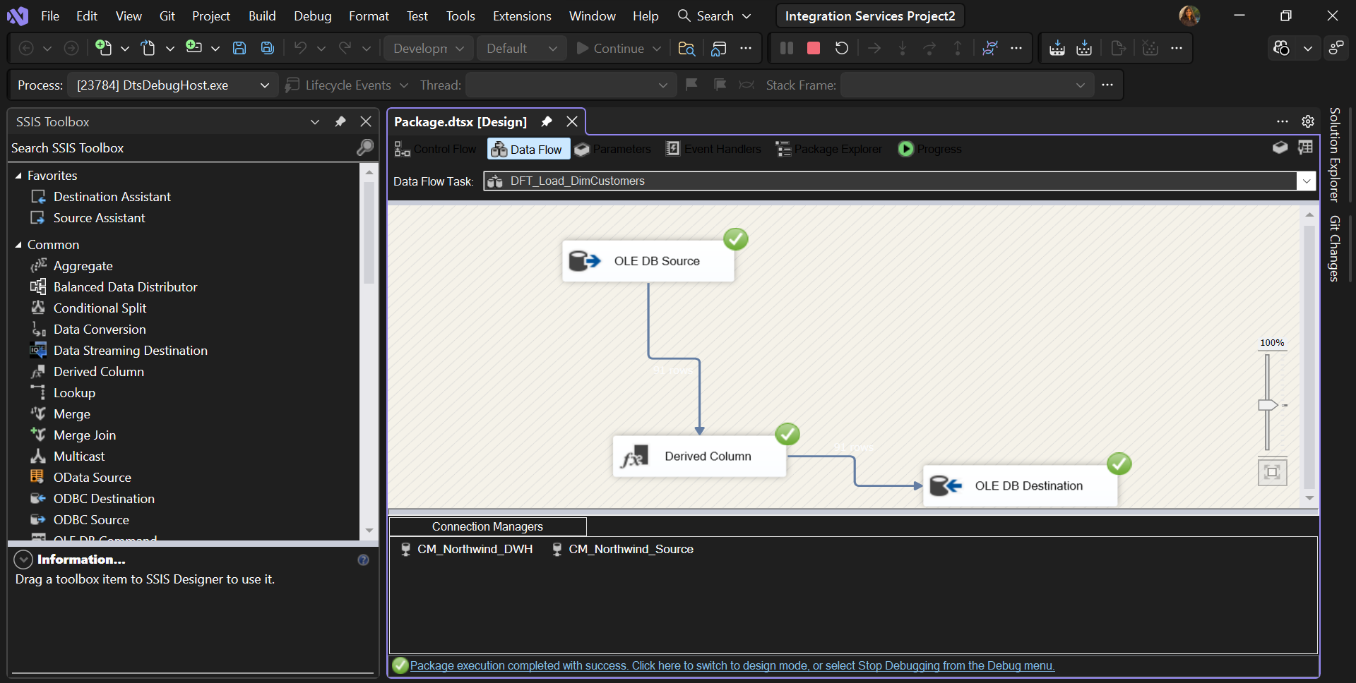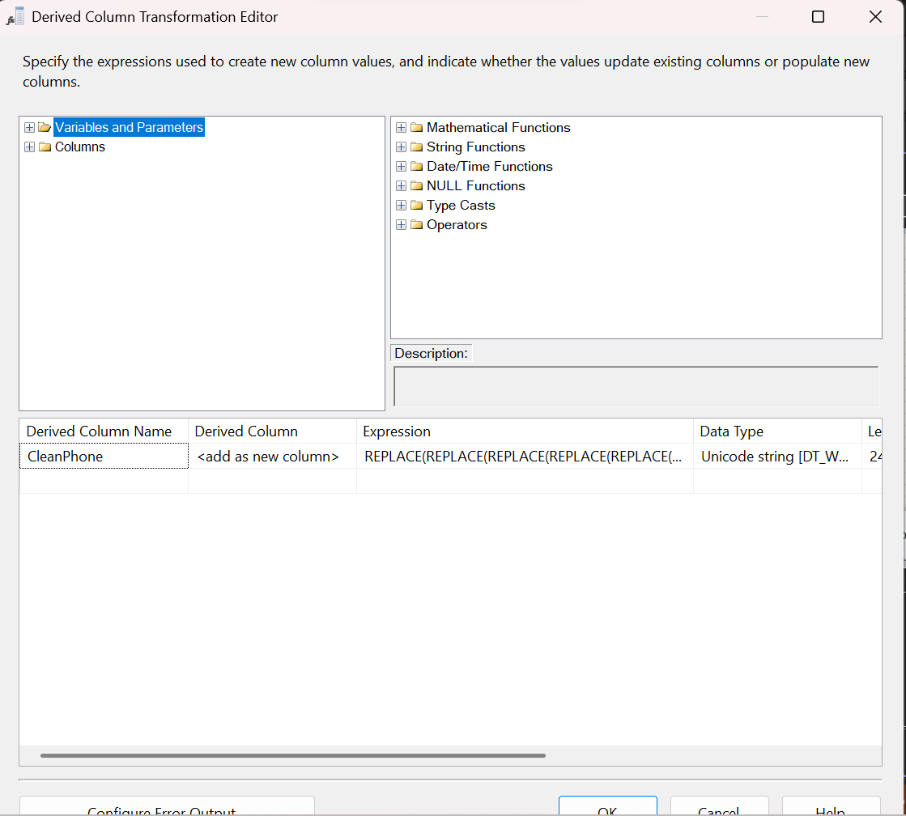
- Shows ETL Data Flow for DimCustomers
- Data extracted using OLE DB Source
- Data transformed using Derived Column
- Data loaded into Data Warehouse (OLE DB Destination)
- Green check marks indicate successful execution

ETL Data Flow for DimEmployees
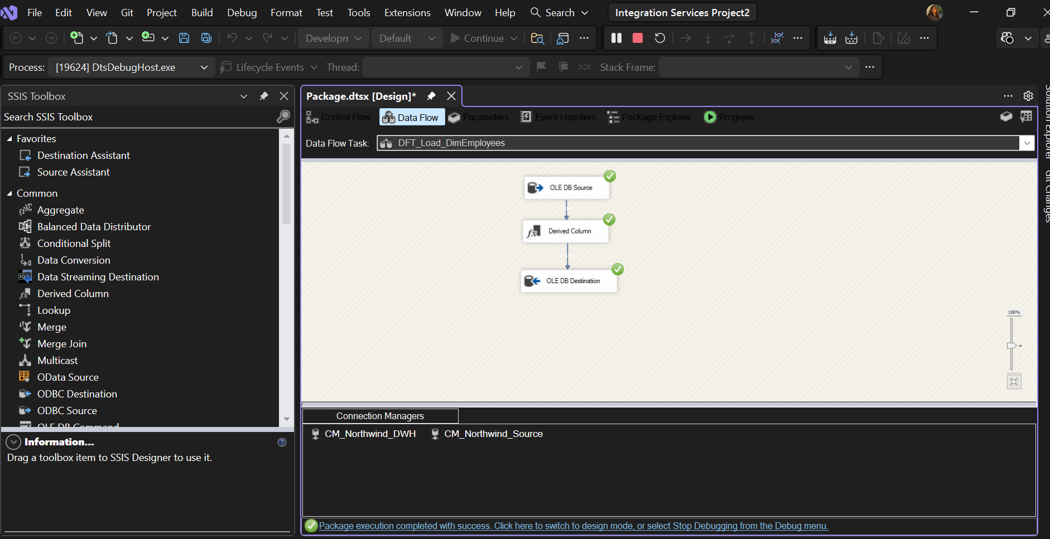

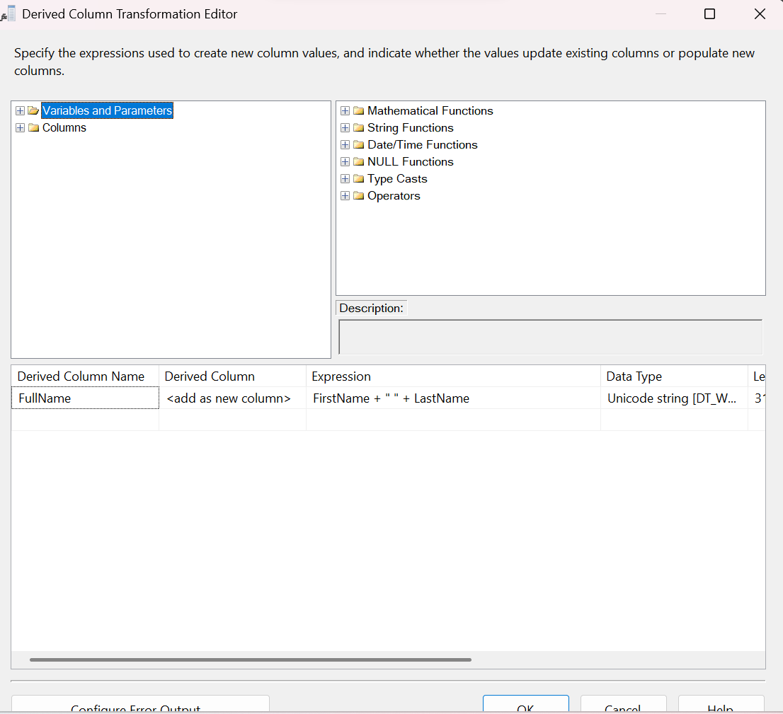

ETL Data Flow for DimProducts
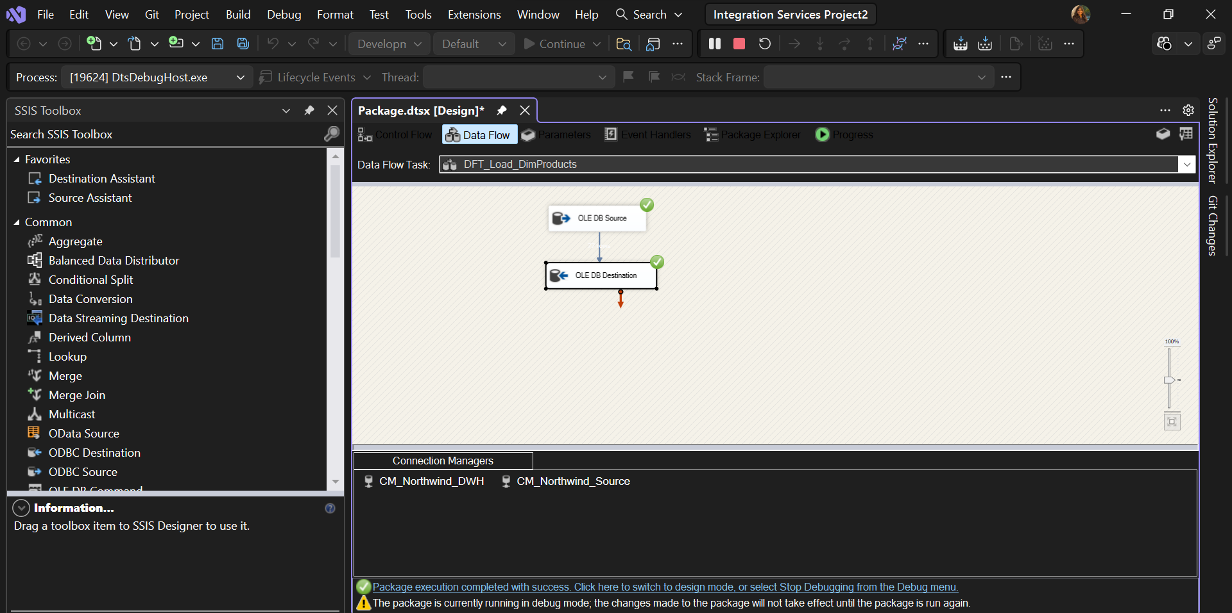
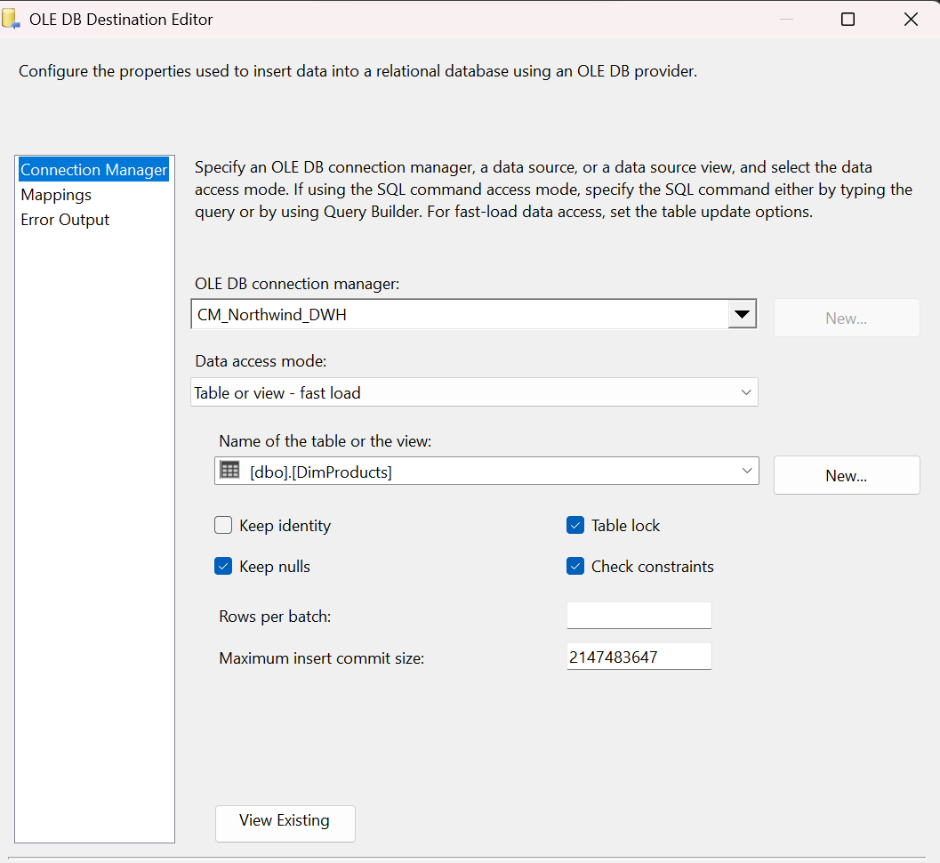
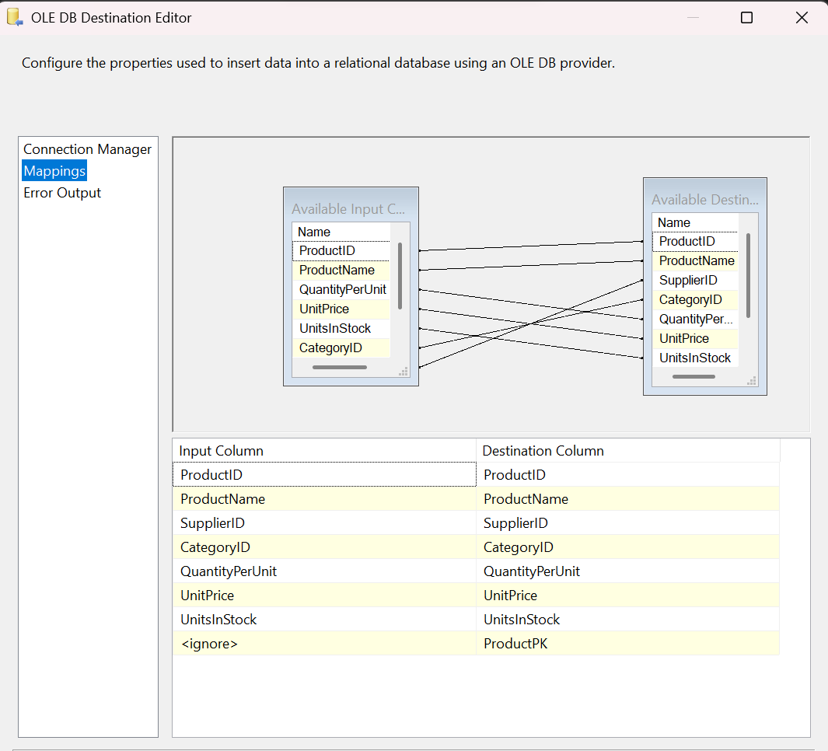

ETL Data Flow for FactOrders

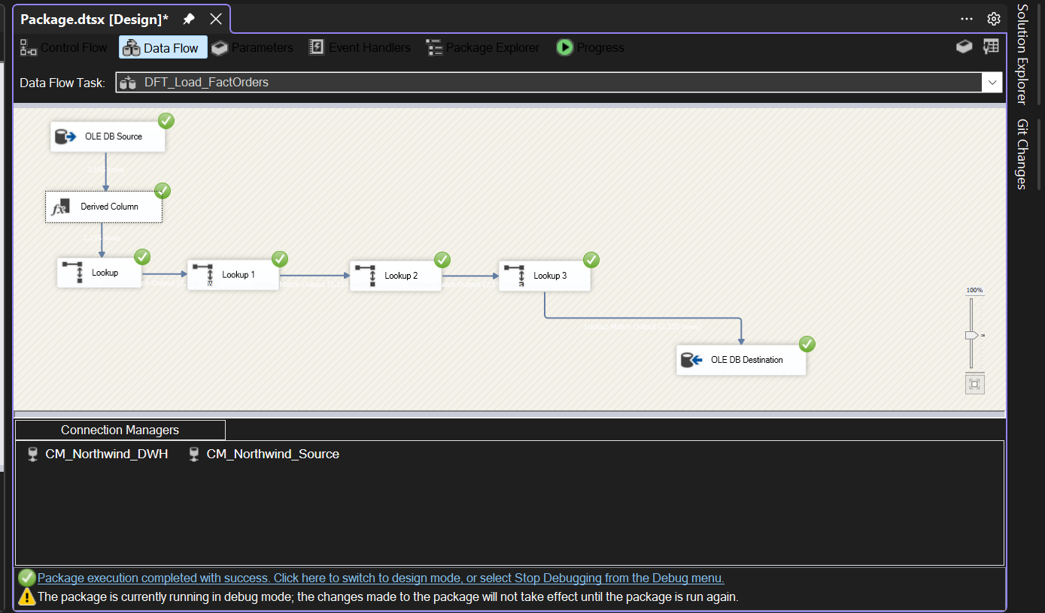

Derived Column Transformation Configuration
- New columns created using expressions
- Date keys generated
- Data type conversions applied

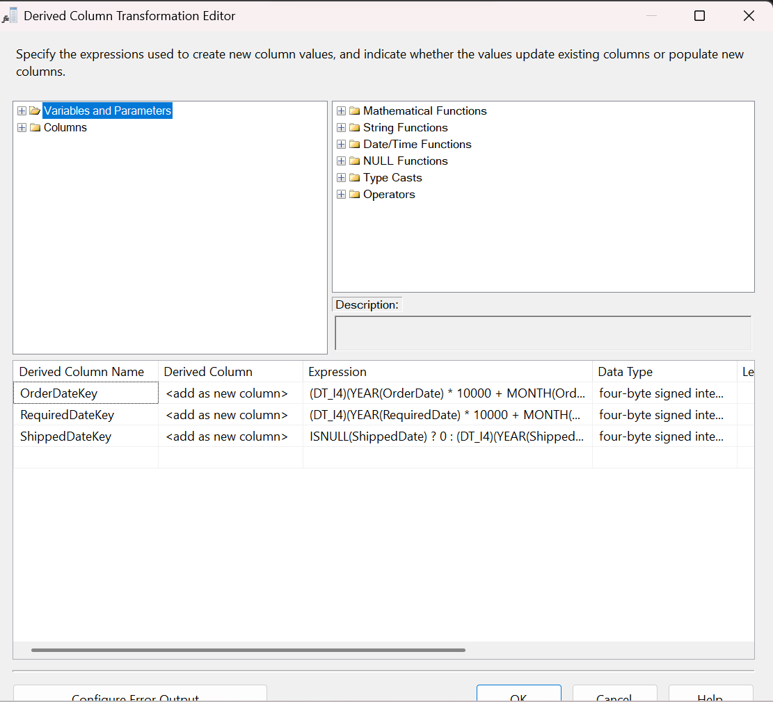

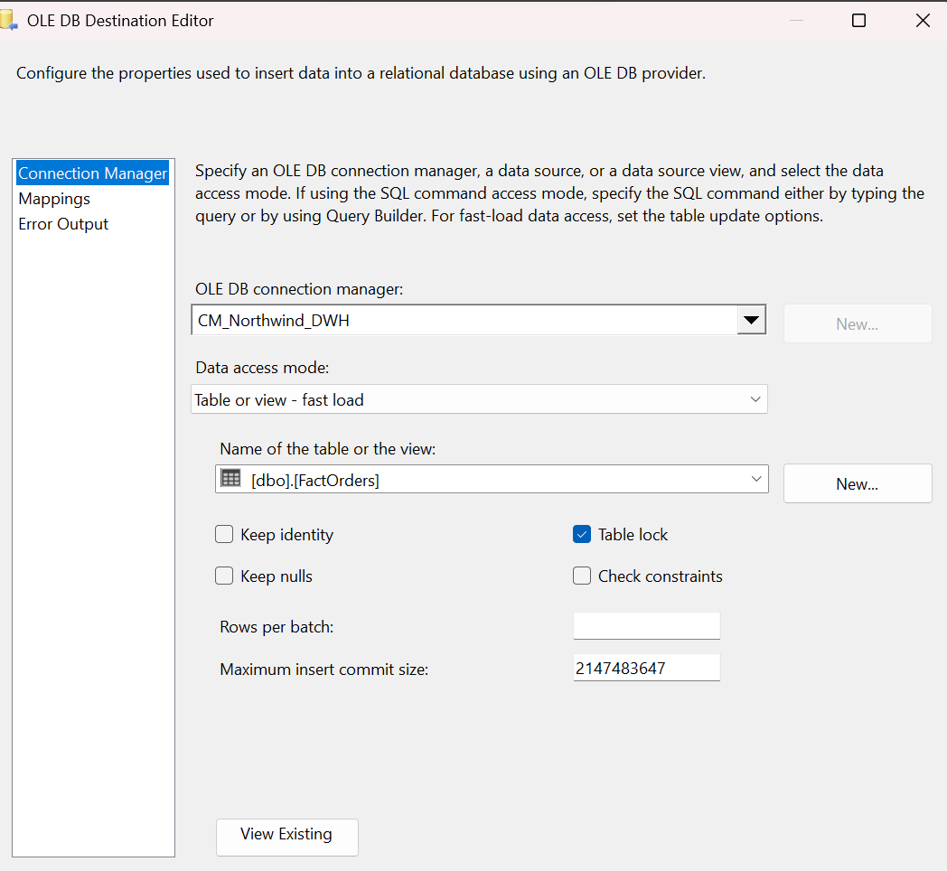

Column Mapping in OLE DB Destination
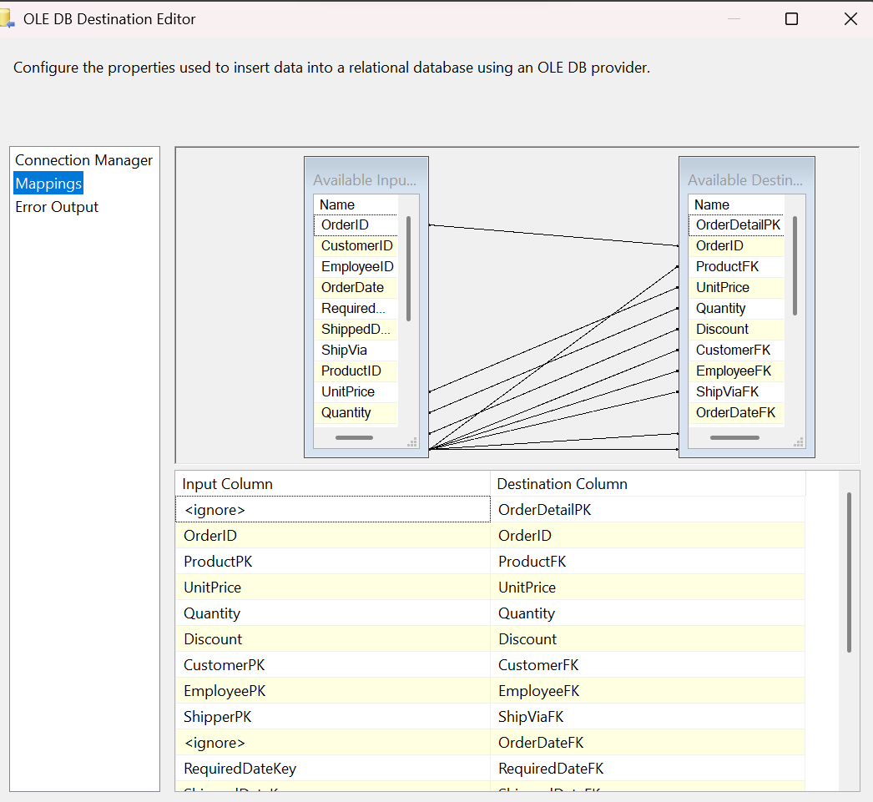

Figure: Structure of FactOrders table
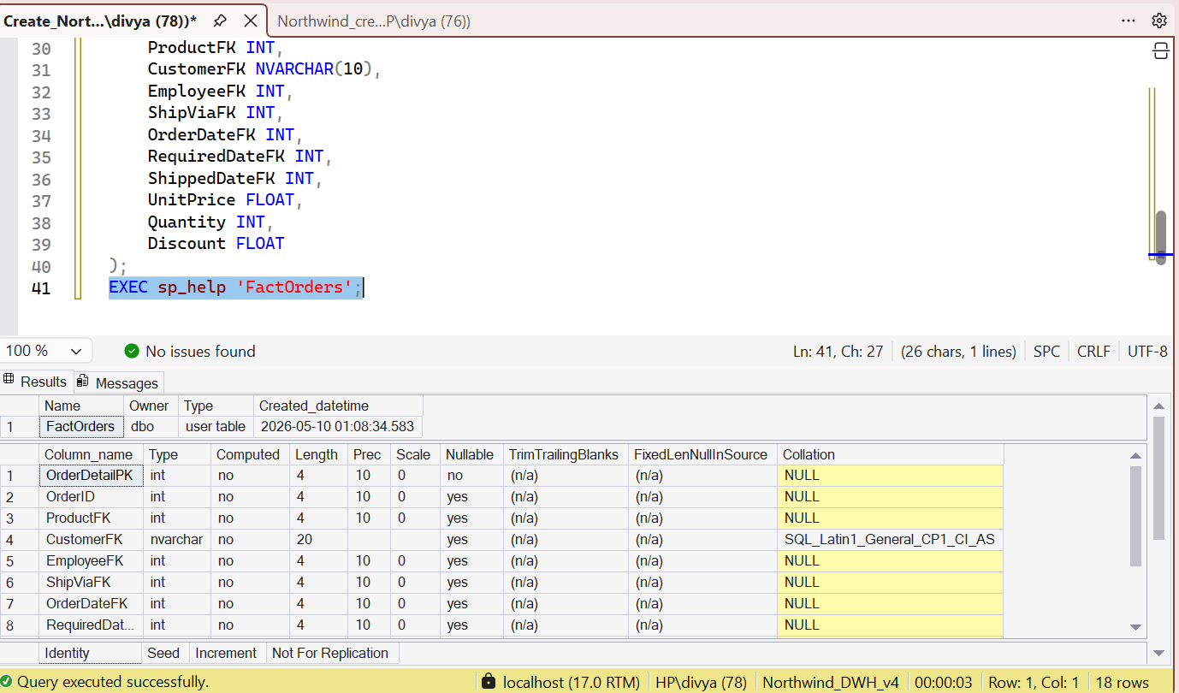

Figure: Data loaded into FactOrders table after ETL execution

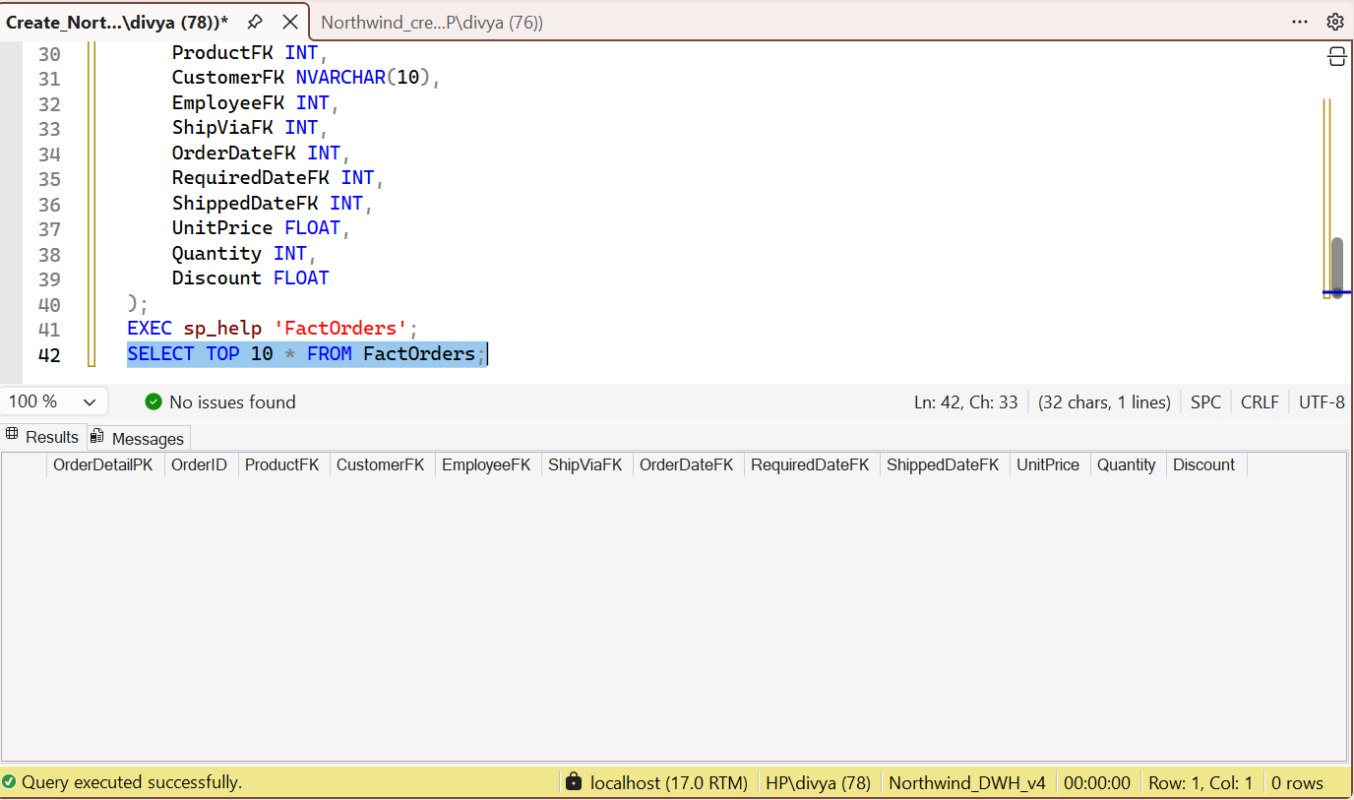

Figure: Total number of records in FactOrders

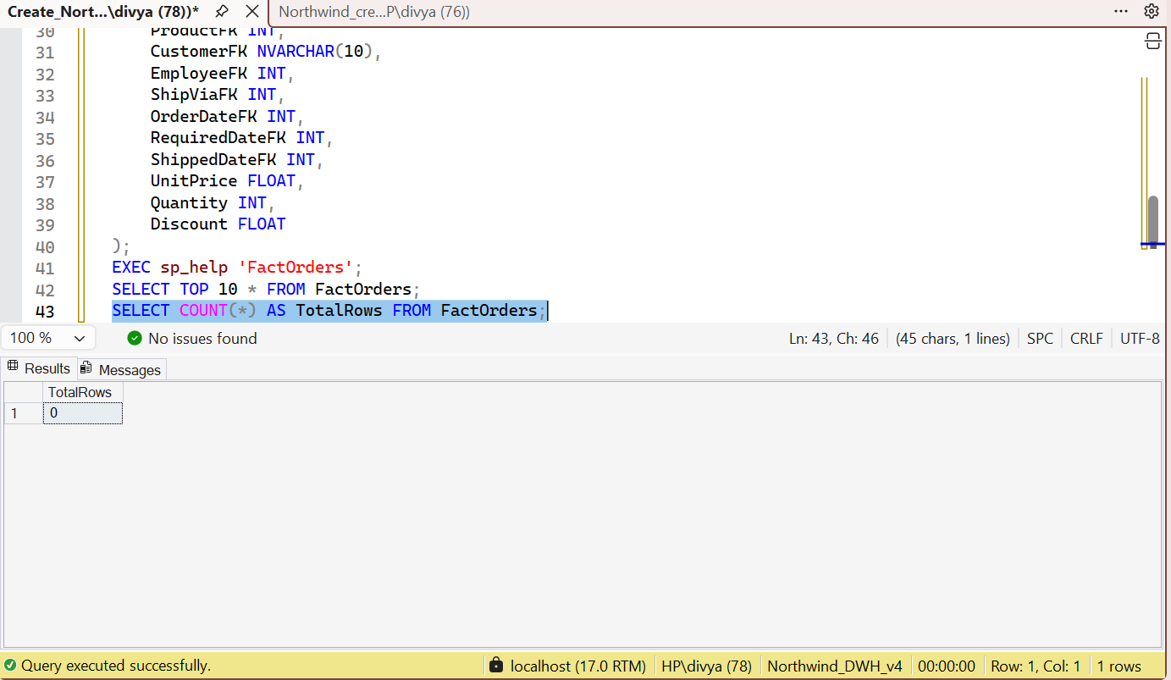

Figure: Sample data from dimension table (DimCustomers)

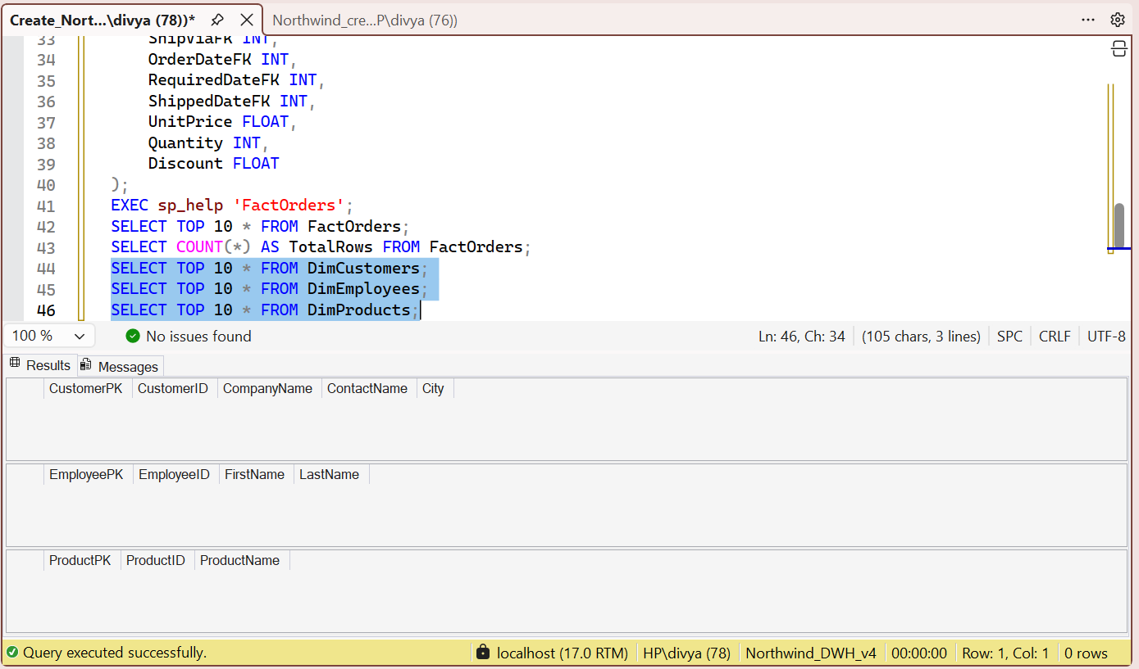

Count of total rows in each table
SELECT COUNT(*) FROM DimCustomers;
SELECT COUNT(*) FROM DimProducts;
SELECT COUNT(*) FROM DimEmployees;
SELECT COUNT(*) FROM FactOrders;
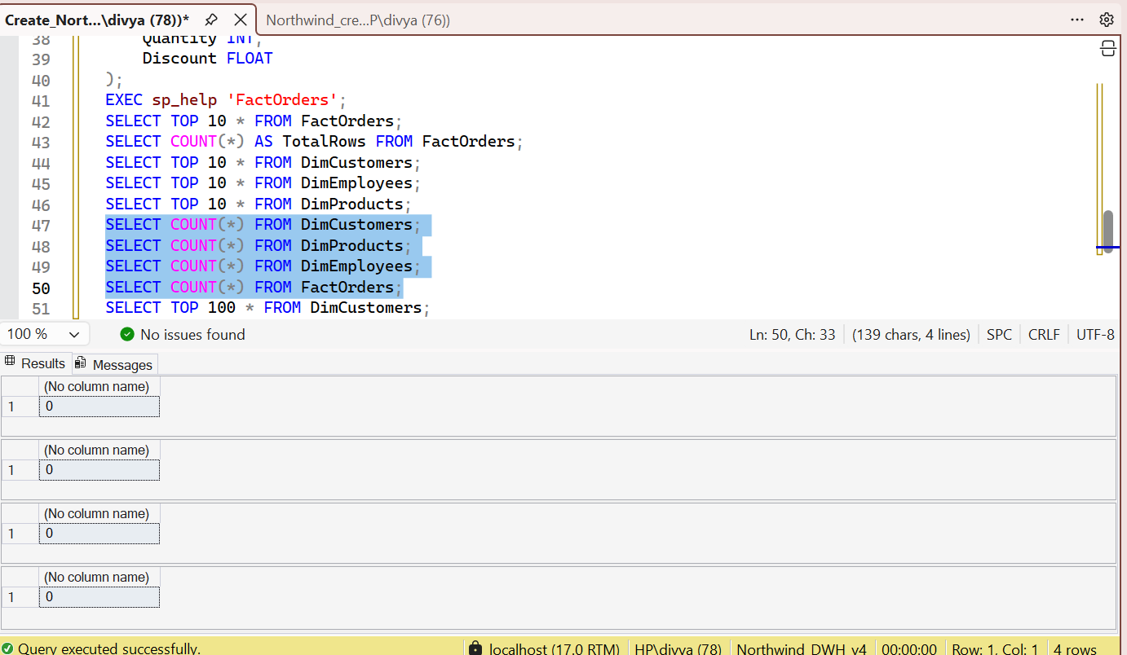

Conclusion
- ETL process was successfully created using SSIS
- Data was taken from the source database
- Data was cleaned and modified using transformations (Derived Column, Lookup)
- Data was then loaded into the data warehouse
- FactOrders table combines data from different dimension tables
- Relationships between tables are properly maintained
- Final data is organized and easy to analyze

